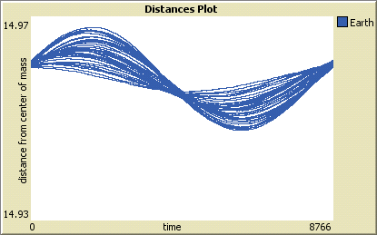Document 1

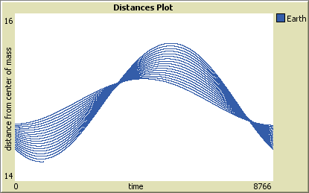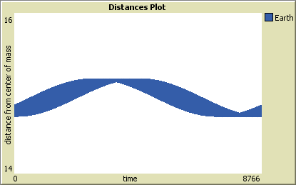  
The following page shows how we used the graph feature of the computer model to massively improve the orbit of planets you can see the development of the orbits though these graphs.

This is a graph showing the orbit of the earth around the sun when we first started making orbits 1. The values we used to set up the orbit of the earth were much less accurate as they were taken from Wikipedia and were averages instead of a specific time.

This is a copy of the same graph tracking the orbit of the earth this is much more consistent and realistic because we started to use information from a NASA data base called horizon. However at this point we used the point (0,0) to orbit around instead of the true centre of mass this is why the distance of the earth from the centre of mass varies so greatly because the sun and the earth as a system move away from the point (0,0). this replicates that movement of the system though the galaxy.

we set up a part of the model to calculate the centre of mass of the system every tick as it moves as you can see the graph now shows that the earth is consistently far from the c.o.m. this not only shows that the model is working but also tell us a lot of information about the planets orbit, its stability, size, period and speed.